What can creekhilife.com do for you?
- Order a transcript with one click of the transcript tab which takes you right there to fill out the info at this site https://needmytranscript.com/TX/League-City/clear-creek-high-school/2305-e-main-st
- Get the latest Creek news as it breaks here http://creekhilife.com/category/news/
- Around Creek gives you more in-depth news and offers links to a few of our favorite organizations http://creekhilife.com/category/around-creek/

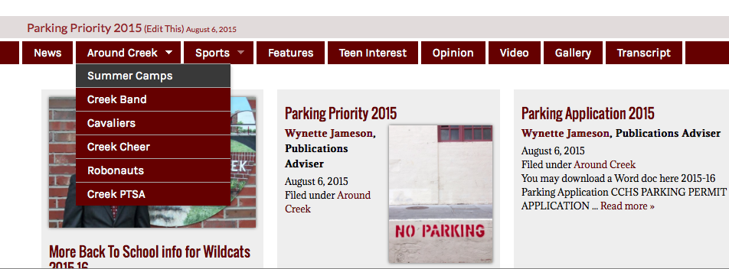

- Sports section will give you our sports stories, athletes of the month and a link to every sport that has a website. http://creekhilife.com/category/sports/

