- We have a brand new section where we will store all documents that parents/students may wish to download http://creekhilife.com/creek-document-downloads/

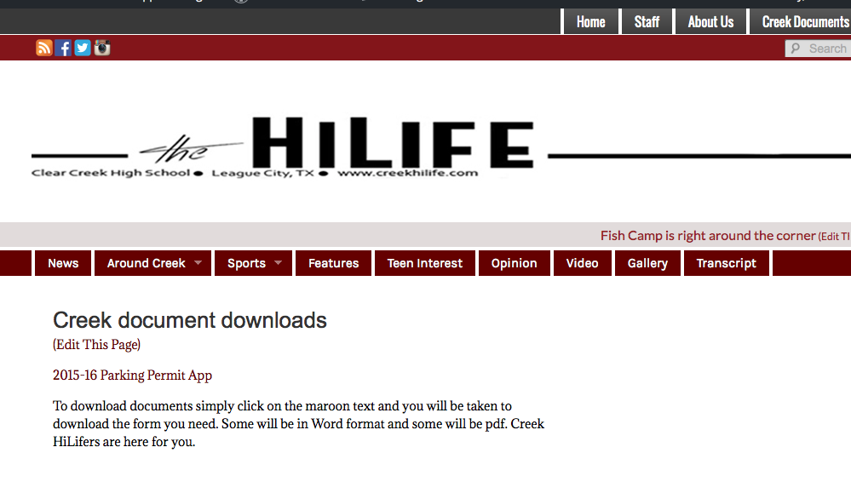
- We also feature the ccisd RSS feed-our twitter account-and a great countdown clock for favorite upcoming events
- 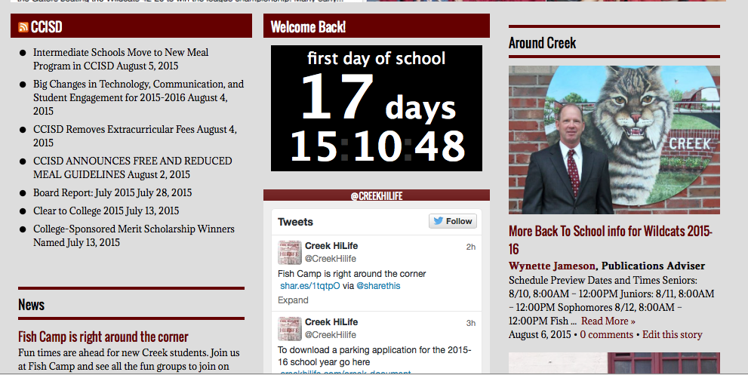
- We will continue to make updates and changes as the year progresses and we see a need for new ideas. We are, as always, here for you at the BEST high school in Texas!

